**WDR MOBILE APPLICATION REQUIREMENTS**

1. The application shall allow login of the data entrants
2. The application shall track the GPRS position of the data entrant before it allows entry of data into the system
3. The application shall allow capturing of observation data using the observation form slip
4. The application shall allow capturing of metar data using the metar form
5. The application shall allow data capturing of the more form fields form
6. The application shall store the data captured in an offline database incase there is no internet connection
7. The application in availability of internet connection shall submit data to the online data repository
8. The application shall submit the data from its repository (database) to the online data repository incase internet is available
9. The application shall logout a user in case it remains dormant without use
10. The application shall validate data entry as per the data validation rules provided. ( here we need to know the validation rules on the form fields, the login credentials)
11. The application shall support a maximum number of login times. (we would want to know the maximum number of times to support. And if the login attempts have reached the maximum should we block the app and the user should report to the office in order to unblock it?)
12. The application shall log who made data entries, the time and date.
13. The application shall display data entered by a given user before submission to allow changes and verifications to be made in case there is need.

**USER INTERFACES FOR THE DIFFERENT MENUS**

This section consists of the different parts that are to be captured in the mobile application

**Login interface**

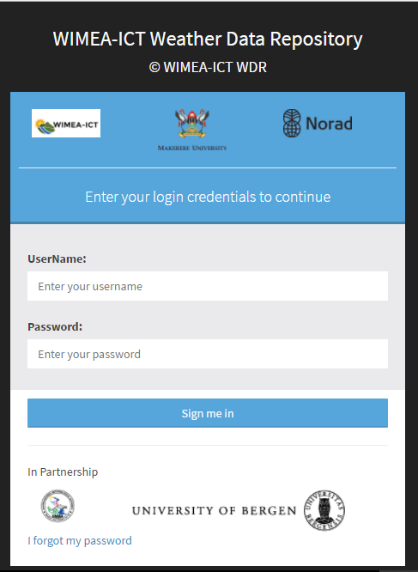

**Observation form slip interface**

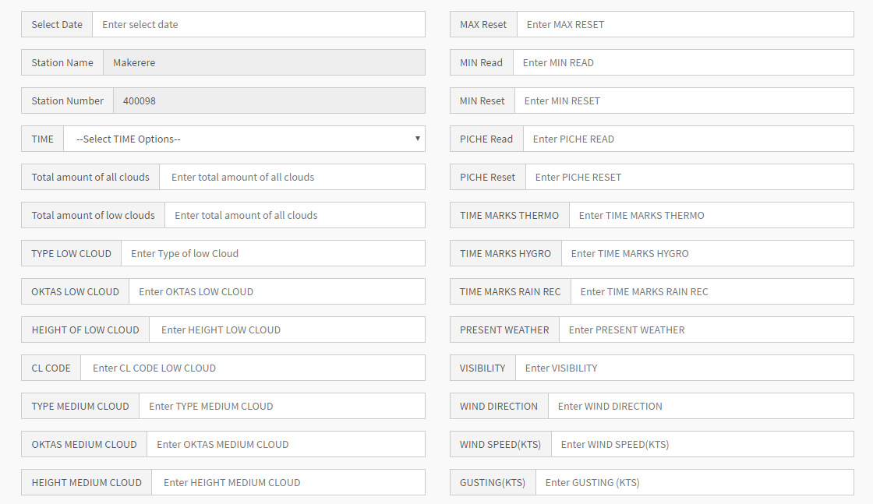

**Observation slip form 2 (continuation of the above form)**

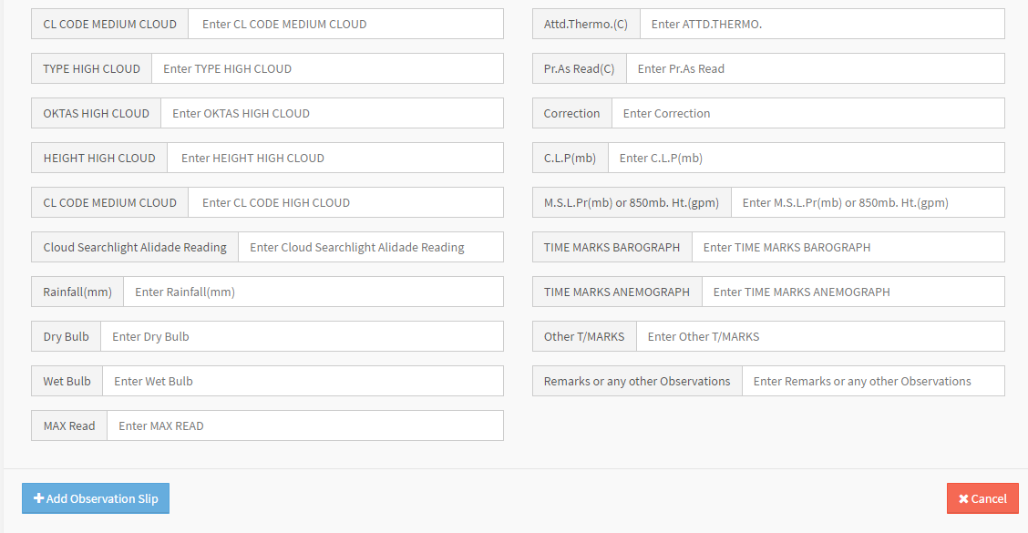

**Metar form part 1**

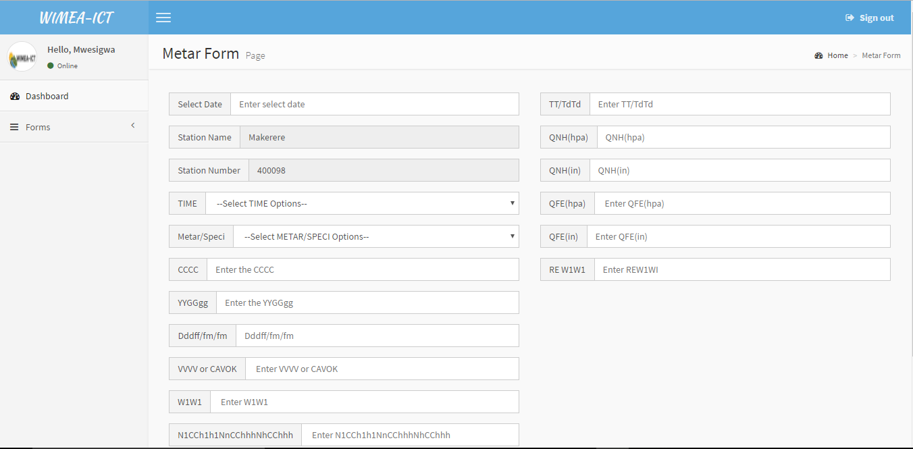

**Metar form part 2**

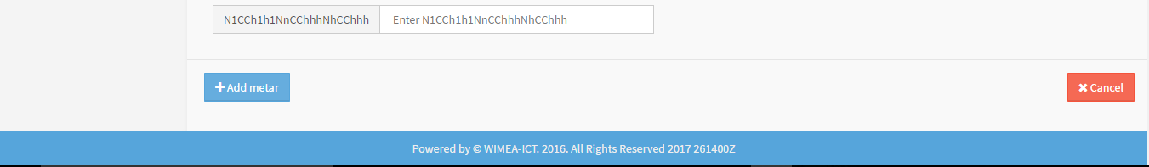

**More form fields form part 1**

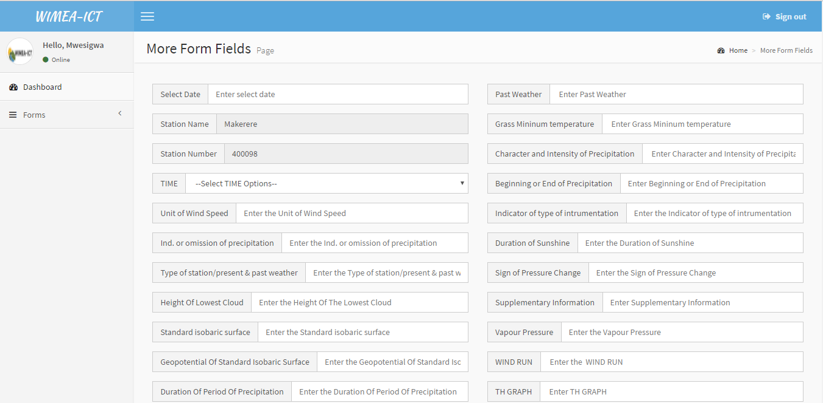

**Other properties**

